This form must be completed in full and signed for by the hirer(s)

Policy Holder’s name:

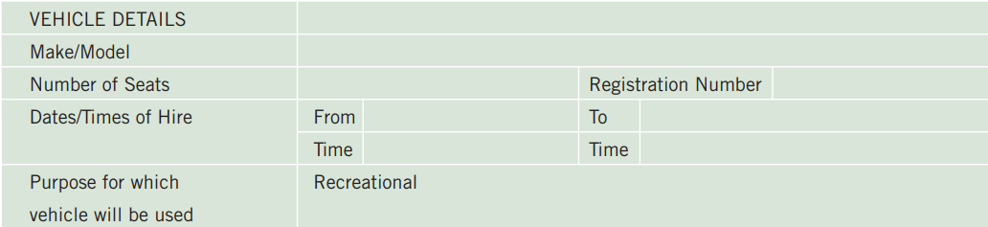

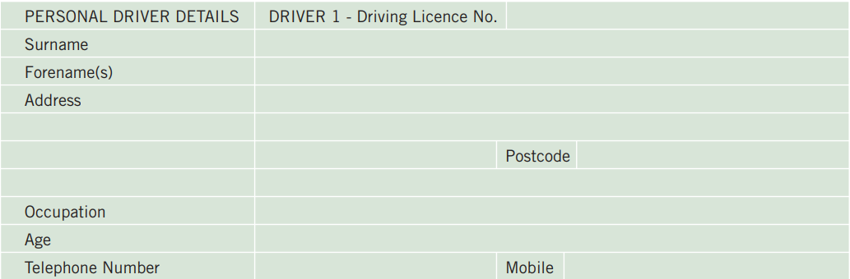

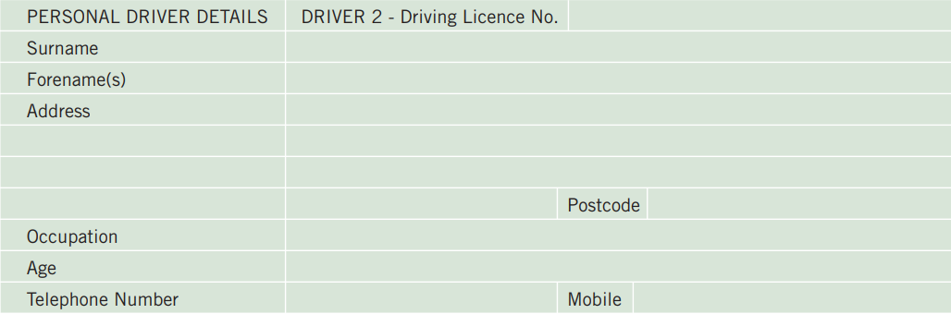

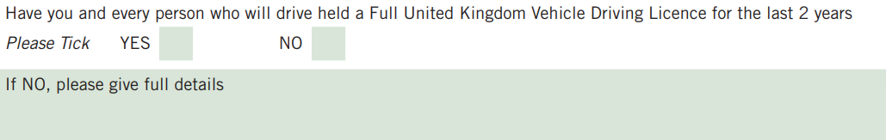

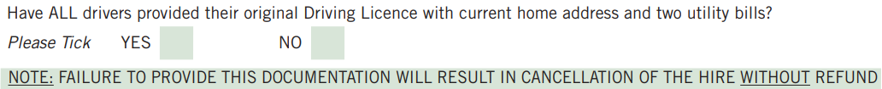

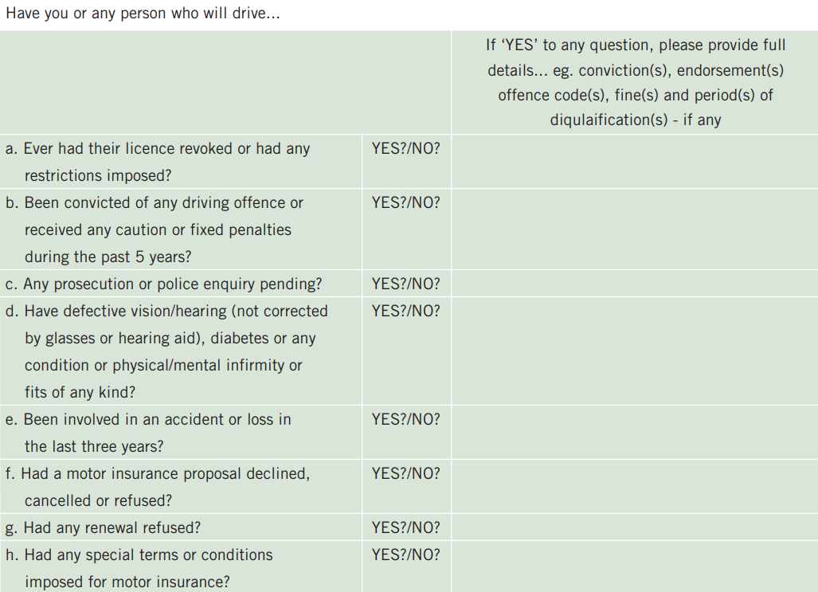

Material Facts... All material facts must be disclosed. Failure to do so could invalidate the insurance in connection with this hiring. A material fact is one that is likely to influence an insurer in the assessment and acceptance of the proposal e.g., a young or inexperienced driver or any offence (including non-motor related offences such as fraud, robbery, theft or handling stolen goods) or, prosecutions pending, or infirmities of any driver. Material facts MUST be disclosed in relation to yourself and ALL other persons to be insured. If you are in any doubt as to whether a fact is material, then it should be disclosed to Rentacampa. It is an offence under the Road Traffic Acts to make any false statement or withhold any material information for the purpose of obtaining a certificate of motor insurance. If any changes in circumstances arise during the period of insurance cover, please contact Rentacampa immediately with full details. A specimen copy of the policy wording is available on request.

Declaration...
☐ | I/we understand the contents of this completed application and I/we declare that the information given is, to the best of my/our knowledge and belief, correct and complete. I/we agree that the statements within this application shall form the basis of the contract between Rentacampa and myself/ourselves.
☐ | I/we understand that my/our information may also be disclosed to regulatory bodies for the purposes of monitoring and/or enforcing the insurer’s compliance with any regulatory rules/codes.
☐ | I/we undertake that the vehicle will NOT be used for the carriage of passengers for hire or reward
☐ | I/we further undertake that ONLY drivers disclosed in this declaration will drive and that to my/our knowledge have not been refused any motor vehicle insurance
☐ | I/we understand that this insurance terminates at the expiry of the period of hire stated
☐ | I/we further agree to be bound by the terms and conditions of the insurance which I have had the opportunity to see and read

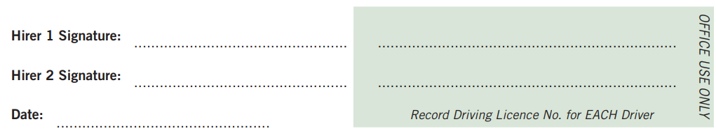

Please note that the vehicle MUST be returned undamaged with the same amount of fuel supplied at hand over, empty of waste water, with an empty toilet cassette and the interior clean and in the same condition as when you took delivery of the vehicle at commencement of hire - otherwise charges may be applied as outlined on Page 4

The following additional charges are payable if appropriate...
- Should the hire vehicle be returned late (after the agreed time stated on the rental agreement):
A late fee of £50 per hour will be charged

- Any parking/other fines and/or penalty charges incurred during the hire period by the hirer(s):
Incurred fees will be charged PLUS an administration fee of £25 per fine/charge

- Should the vehicle not be returned with the interior in a clean condition:
A valeting/upholstery cleaning fee of £50 will be charged

- Fuel top-up charge:
The cost of refilling the fuel tanks to the position they were in at the hand over PLUS an associated administration fee of £25

- Toilet cassette:
A fee of £50 will be charged if, on return, the vehicle toilet cassette has not been emptied

- Waste water:
A fee of £50 will be charged if, on return, the vehicle waste water has not been emptied

- Vehicle damage:
Cost of any damage to vehicle or third-party property - subject to the insurance

- Costs incurred:
Any cost(s) incurred as a result of any breach by the hirer(s) of this agreement

- Demurrage:
Daily rental cost(s) whilst the vehicle is off fleet – e.g., for accident repairs etc.

- Additional cost(s):
Any cost(s) over and above the security deposit amount should that amount be exceeded

- Vehicle recovery:
Any cost(s) incurred recovering a vehicle

- Gross negligence:
Rentacampa reserve all rights to recover any cost(s) incurred in order to return the vehicle to the state in which it was when the hire commenced at hand over

